5

Some useful information:

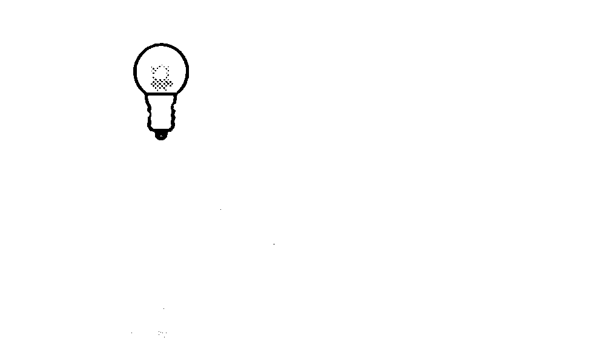  The two contact points on a torch battery are at the ends: |  | The two contact points on a torch bulb are the tip and the screw thread:
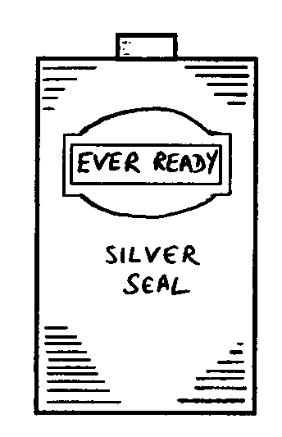

_______________________________________________________________

(a) Is this bulb lit? Yes 
Tick ONE box ():
No 

(b) If you have ticked ‘No’, could it be made to light by adding one wire?
Tick ONE box (): Yes 

No 

(c) If you have said ‘Yes’, please draw the wire on to the diagram.

_______________________________________________________________

(d) Is this bulb lit? Yes 
Tick ONE box ():
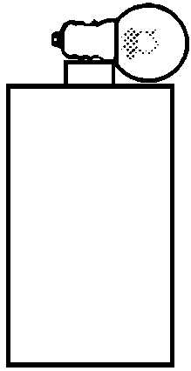
No 
(e) If you have ticked ‘No’, could it be made to light by adding one wire?
Tick ONE box (): Yes 

No 

(f) If you have said ‘Yes’, please draw the wire on to the diagram.

